**Project Initialization and Planning Phase**

| Date | 15 March 2024 |
| --- | --- |
| Team ID | LTVIP2025TMID26725 |
| Project Name | Visualization Tool for Electric Vehicle Charge and Range Analysis |
| Maximum Marks | 3 Marks |

**Customer Problem Statement Template:**

|  |  |  |
| --- | --- | --- |
| I’am | An EV Owner(customer) | who frequently drives long distances |
| I’am Trying To | Finding fast charging station during my trips | Find a rerliable and fast charging station during my trips |
| But | unavailable | Charging stations are unavailable or too far apart |
| Because | Networks are not well | There is no real-time availability tracking,and charging stations are not well integrated |
| Which makes me feel | frausteted | Frausted , anxious about Range , and hesitant to take lond trips in EV. |
|  |  |  |

**Example:**

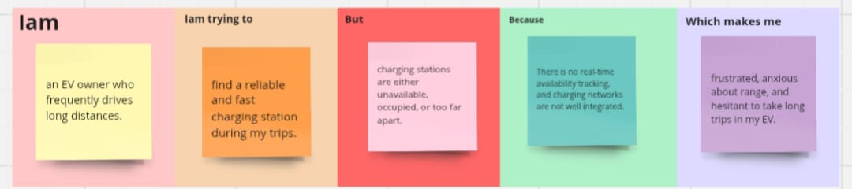

|  |  |  |  |  |  |
| --- | --- | --- | --- | --- | --- |
| **Problem**  **Statement (PS)** | **I am**  **(Customer)** | **I’m trying to** | **But** | **Because** | **Which makes me feel** |
| PS-1 | An EV owner who frequently drives long distances | Find a rerliable and fast charging station during my trips | Charging stations are unavailable or too far apart | There is no real-time availability tracking,and charging networks are not well integrated | Frausted , anxious about Range , and hesitant to take long trips in EV. |
| PS -2 | A fleet manager overseeing multiple electric vehicles for commercial operations. | Ensure efficient route planning and minimize downtime due to charging. | Charging stations are often occupied, and charging times vary unpredictably. | There is no integrated system to monitor real-time station availability and optimize charging schedules. | Frustrated, as delays increase operational costs and reduce overall fleet efficiency. |